Activity 1: Create an agent in Copilot Studio

In this activity, you will follow along with the demonstration of creating an AI agent in Copilot Studio.

Exercise 1: Open Copilot Studio and provision an agent
Begin by opening Copilot Studio.
- Open Copilot Studio in a browser: https://copilotstudio.microsoft.com.
- Sign in if prompted using your Microsoft credentials.
- A welcome message with update messages may appear. Select Close.
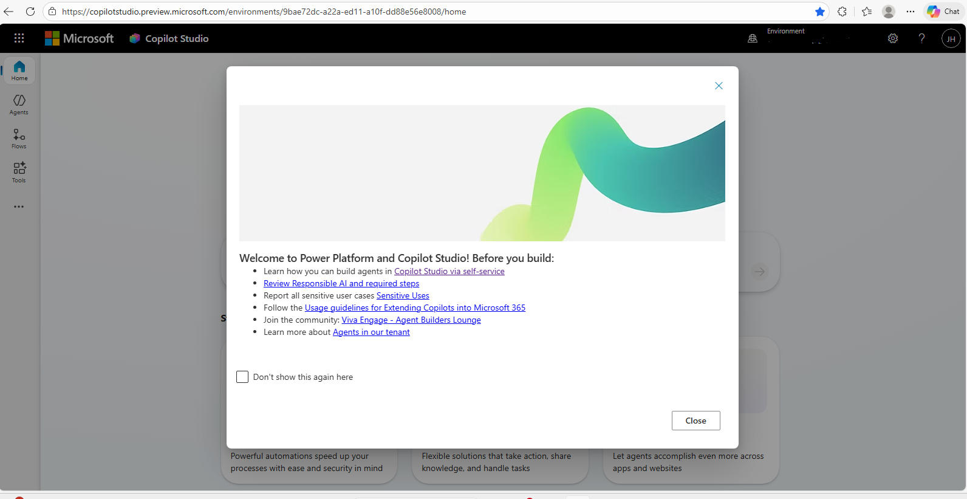
- From the home screen you can build an agent in any of three ways:
  - Begin describing the agent you would like to build in the chat box under the words “What would you like to build?”
  - Select Create an agent in the center box below the chat box.
  - Select Agents from the side bar.
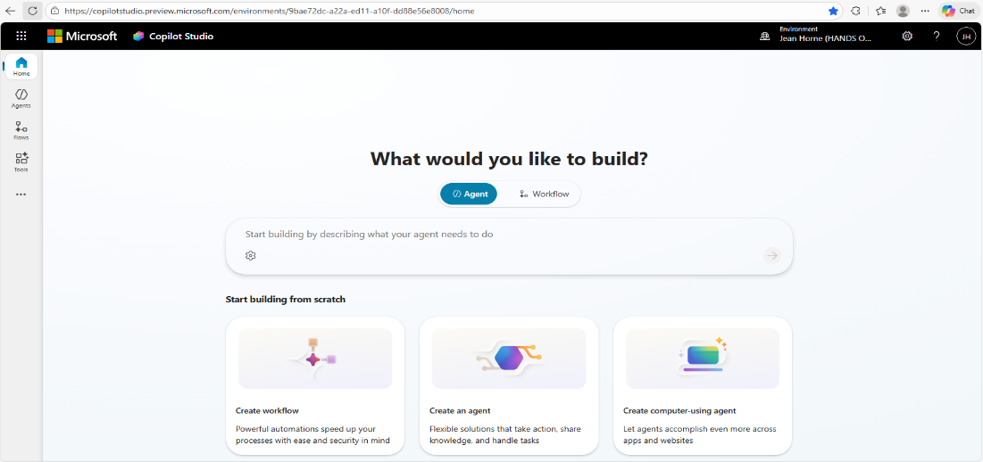
- The agent is provisioned and opens. Note the tabs across the top of the menu next to your agent’s default name, for ways to modify and extend your agent.
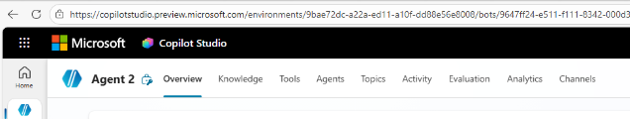

Exercise 2: Customize your agent
Once your agent is provisioned, you will note the screen is divided into two sections. On the left is the section containing fields to customize the agent. On the right is where the agent will appear as you build it.
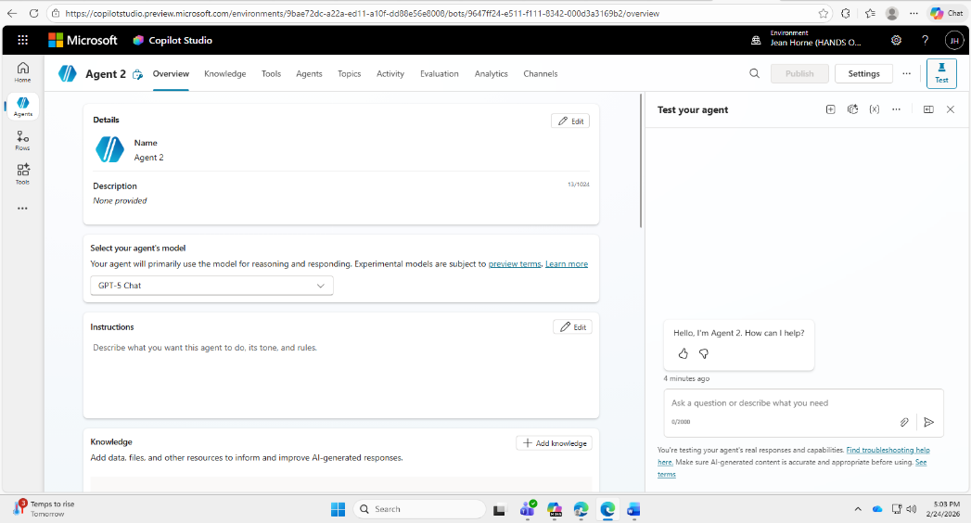

- The agent is assigned a default name of “Agent #” where # is the number of agents you have built in Copilot Studio. It is also given a default icon. To change either of these:
  - In the Details section of the screen, select Edit.
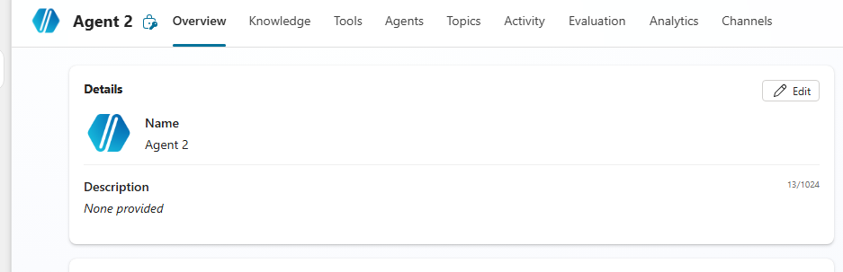

  - Enter the new agent name in the Name field.
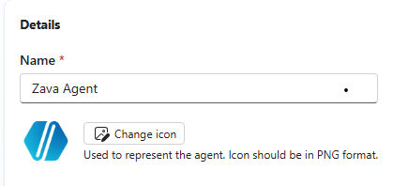

  - Select Change icon. Note the requirement that the image must be in PNG format and that any image over 72 KB will be resized.
  - Select Save when you are done.
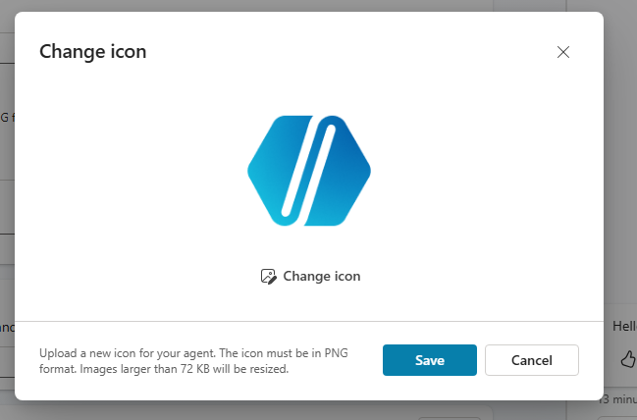
  - Select Save again. Your custom agent name and icon will appear.
- In the Details pane, add a Description of your agent.
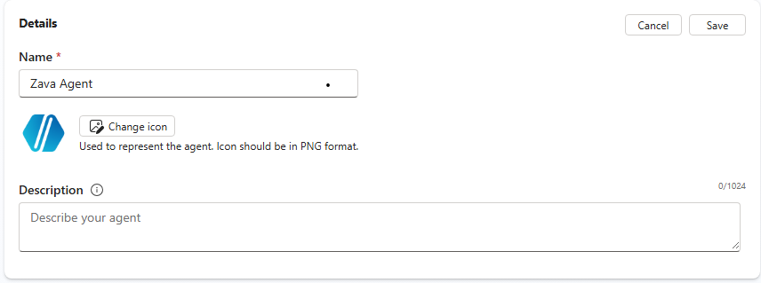
- In the Select your agent’s model field, a default agent model appears. If you want to change it, select the drop-down menu to pick from the available model options. A brief description of each model appears in the list to help you decide.
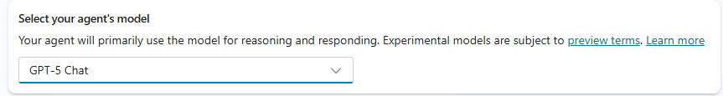
- In the Instructions field, add the instructions you want the agent to follow.
  - Select Edit.
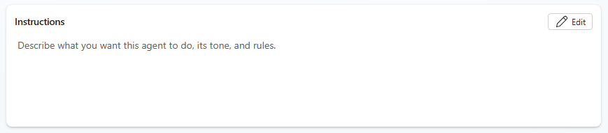
  - Enter the instructions in plain language, describing what you want the agent to do.
  - When you complete the instructions, the Save button will become active. Select Save.
- In the Knowledge pane, you will add data and other knowledge sources you want the agent to use to complete its tasks.
  - Toggle on or off the option for Web Search to be enabled. If it is on, the agent will search all public websites when completing tasks. If it is off, the agent will only use the knowledge sources you upload.
  - To upload knowledge sources, select Add knowledge in the center of the pane (or the + Add knowledge button).
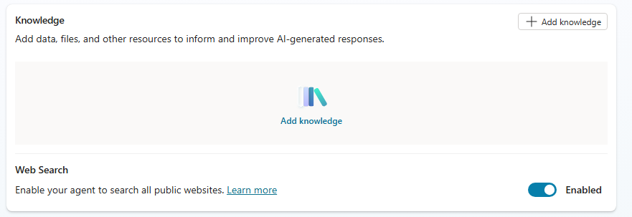
  - In the Add knowledge window, you have several options to ground the agent with knowledge:
    - Select the search bar to search for your knowledge source by type (public website, SharePoint, and so on) and then by URL.
    - Select Upload file to upload files from your device.
    - Drag and drop files into the Upload file field.
    - Select one of the other file sources listed at the bottom of the screen, such as SharePoint or Dataverse.
  - Your selected knowledge sources will appear in a list in the Knowledge field of the main agent window.
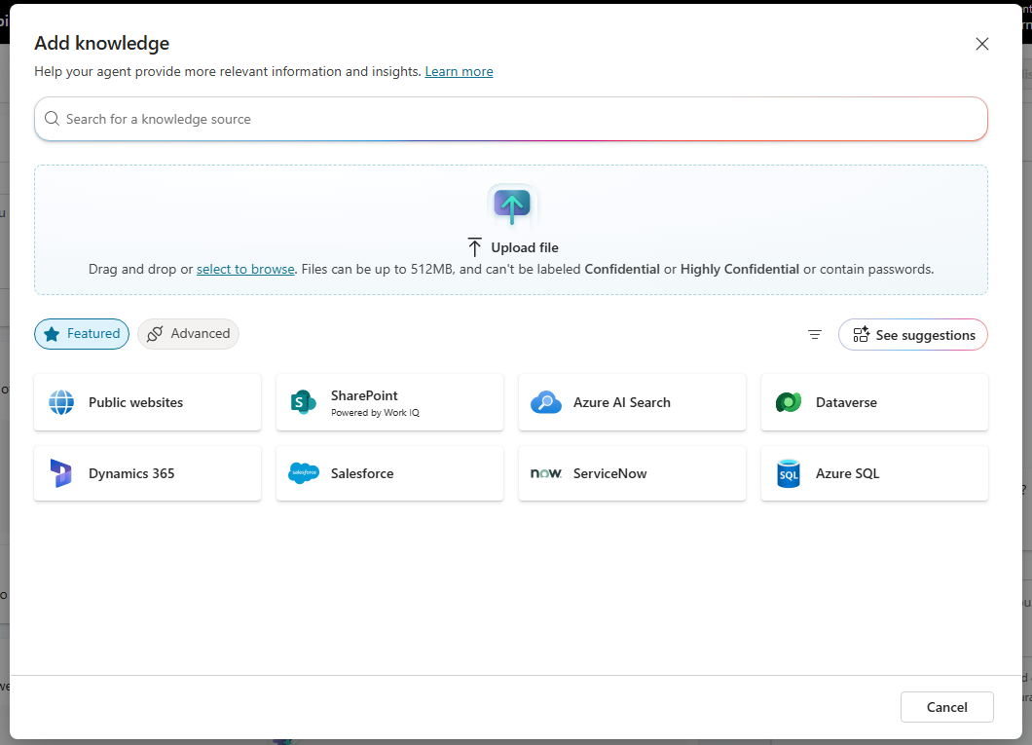
- Scroll down the agent home page to see additional panes to customize your agent. The next pane is for Tools.
  - Select the + Add tool button or the Add Tool field in the center of the pane.
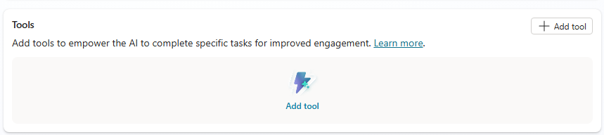
  - In the Add tool window, you have several options:
    - Search for the tool you need in the search bar.
    - In the Create new field, select a tool type.
    - Select a tool from the list of tools provided. Tabs offer categories of tools, such as connectors, prompts, and flows.
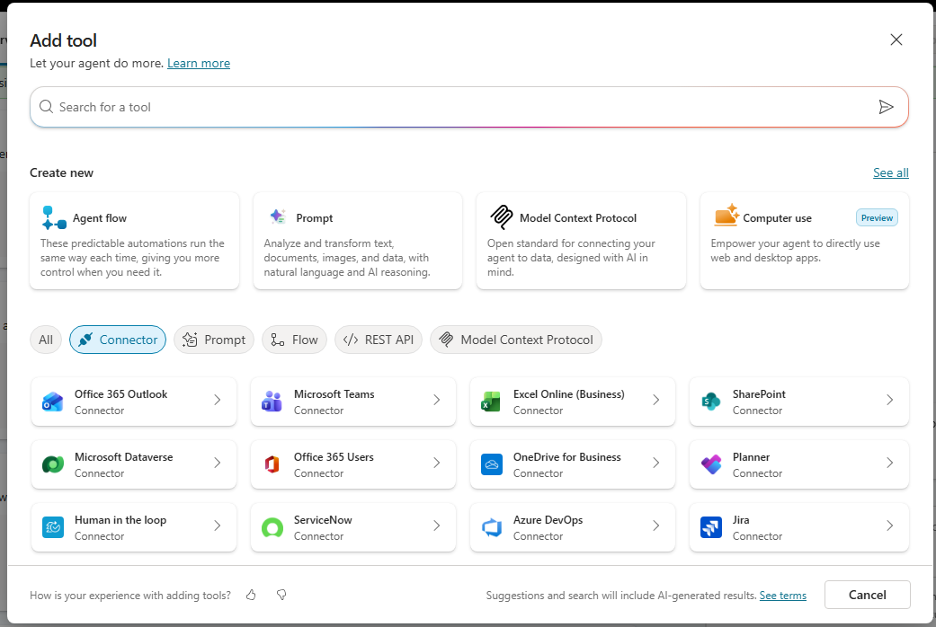
- The next pane allows you to add Triggers.
  - Select the + Add trigger button or the Add trigger field in the center of the pane.
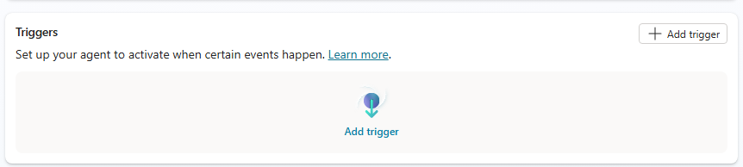
  - In the Add trigger window, select Search to find a specific trigger or select from the featured triggers provided. 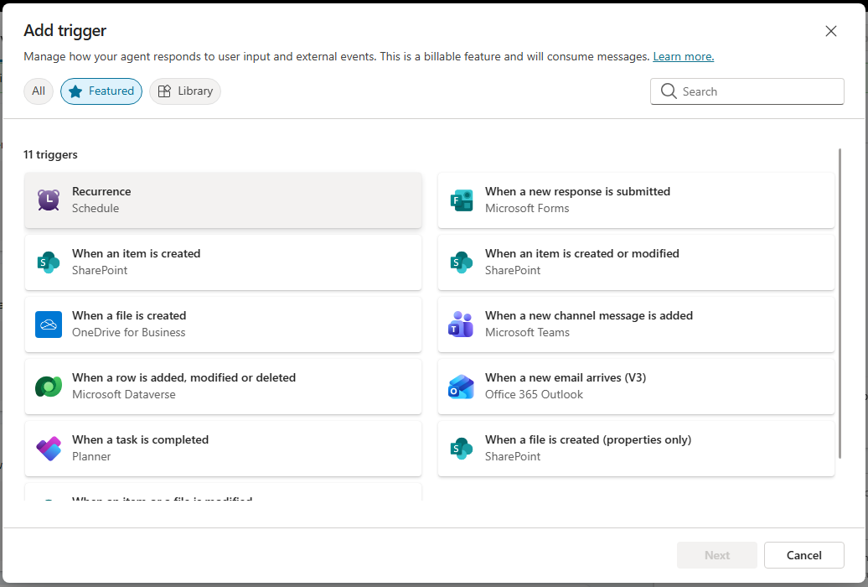
  - Select Next.
  - Select options to manage how the trigger you chose will interact with the agent. Note whether the trigger you chose is a billable option or not.
- The Agents pane allows you to connect another agent to the one you are building.
  - Select the + Add agent button or the Add agent field in the center of the pane.
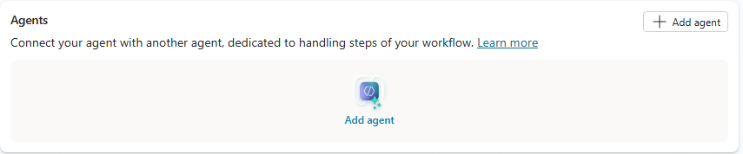
  - In the Choose how you want to extend your agent window, choose one of the following options:
    - Search for one of your existing agents in the search bar.
    - Select New child agent to build a new connected agent.
    - Select Connect to an external agent to choose an agent outside of your own Copilot agents.
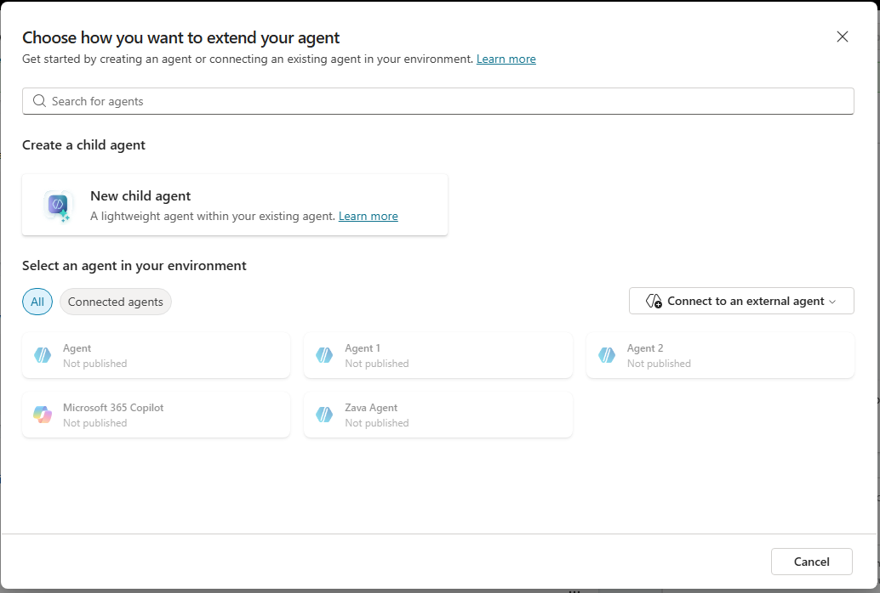
- The next pane allows you to add Topics to your agent. A topic is a conversational directive, specific guidance to the agent on how to interact with the user to perform a task.
  - Select one of the topics shown on the screen or select See all for the full list of default topics available.
  - Select + Add topic.
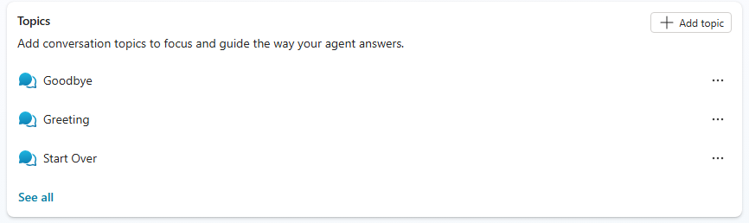
  - In the Add from description with Copilot window:
    - Enter a name in the Name your topic field.
    - In the Create a topic to… field, describe what you want the agent to do for this user interaction.
    - Or, you can select a topic from the examples provided, or select View more examples for other options.
    - Select Create.

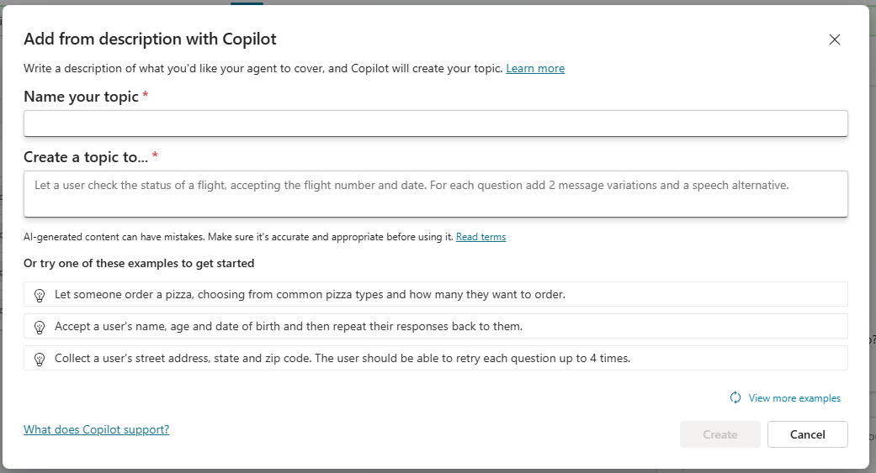
- The final pane allows you to enter Suggested prompts, the default preconfigured prompts that appear when the agent starts, to help the user get started.
  - Select the + Add suggested prompts button or the Add suggested prompts field in the center of the pane.
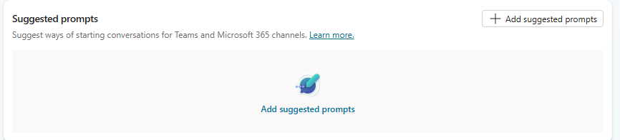

  - In the Suggested prompts window:
    - Enter the Title of your prompt. Note the character limit of 30.
    - Enter the Prompt itself. Note the character limit of 4,000.
    - Repeat until you have entered all the prompts you would like to create.
    - Select Save.
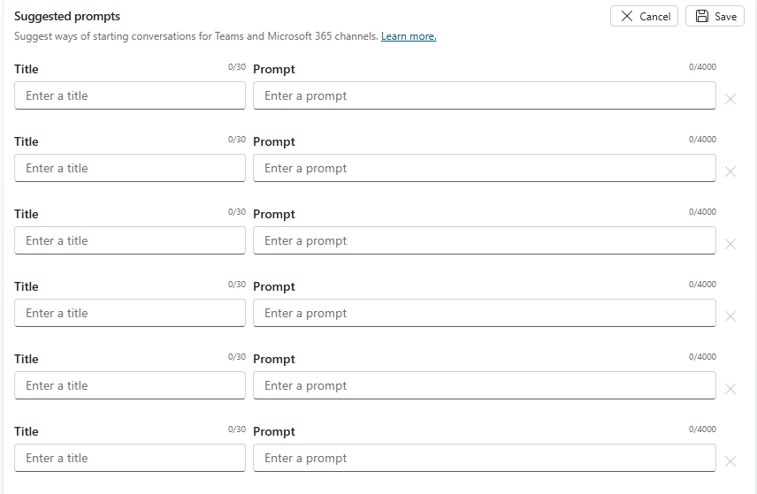
  - Once your agent is configured, select Test to interact with the agent.
